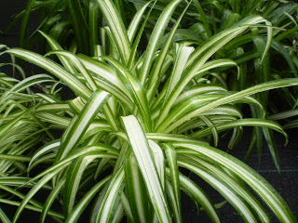

**Spider Plant, Airplane Plant**

*Chlorophytum comosum*

(<https://1.bp.blogspot.com/_eaKbvlcIK10/R5_tedEuRdI/AAAAAAAAAtU/PqPrsbwVgeo/s320/chlorophytum+comosum+(own)2.jpg>)

**Category:**

Tropicals and Tender Perennials

**Water Requirements:**

Requires consistently moist soil; do not let dry out between waterings

**Where to Grow:**

This plant is suitable for growing indoors

**Height:**

18-24 in. (45-60 cm)

**Spacing:**

12-15 in. (30-38 cm)

**Hardiness:**

USDA Zone 9b: to -3.8 °C (25 °F)

USDA Zone 10a: to -1.1 °C (30 °F)

USDA Zone 10b: to 1.7 °C (35 °F)

USDA Zone 11: above 4.5 °C (40 °F)

**Sun Exposure:**

Light Shade

**Danger:**

N/A

**Bloom Color:**

White/Near White

**Bloom Time:**

Late Winter/Early Spring

Mid Spring

Late Spring/Early Summer

**Foliage:**

Grown for foliage

Smooth-Textured

**Soil pH requirements:**

6.1 to 6.5 (mildly acidic)

6.6 to 7.5 (neutral)

**Patent Information:**

Non-patented

**Propagation Methods:**

By dividing the rootball

Plant is viviparous

**Seed Collecting:**

Bag seedheads to capture ripening seed

Allow pods to dry on plant; break open to collect seeds